Tela de remoção de carros

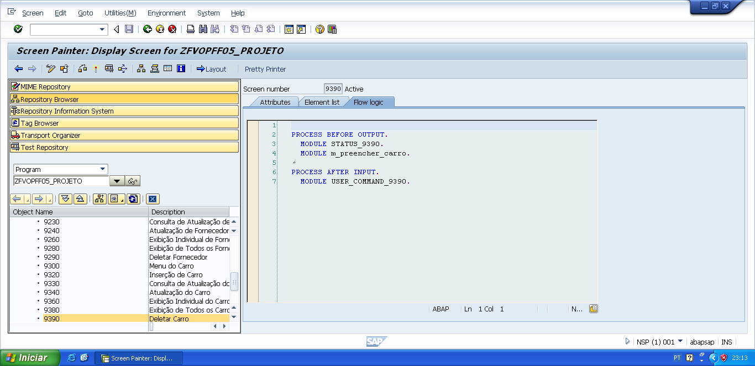

PROCESS BEFORE OUTPUT.  
  MODULE STATUS_9390.  
   MODULE m_preencher_carro.

*&---------------------------------------------------------------------*  
*&      Module  STATUS_9390  OUTPUT  
*&---------------------------------------------------------------------*  
*       text  
*----------------------------------------------------------------------*  
MODULE status_9390 OUTPUT.  
  SET PF-STATUS 'STATUS9390'.  
  SET TITLEBAR 'TITULO9390'.  
  
ENDMODULE.                 " STATUS_9390  OUTPUT

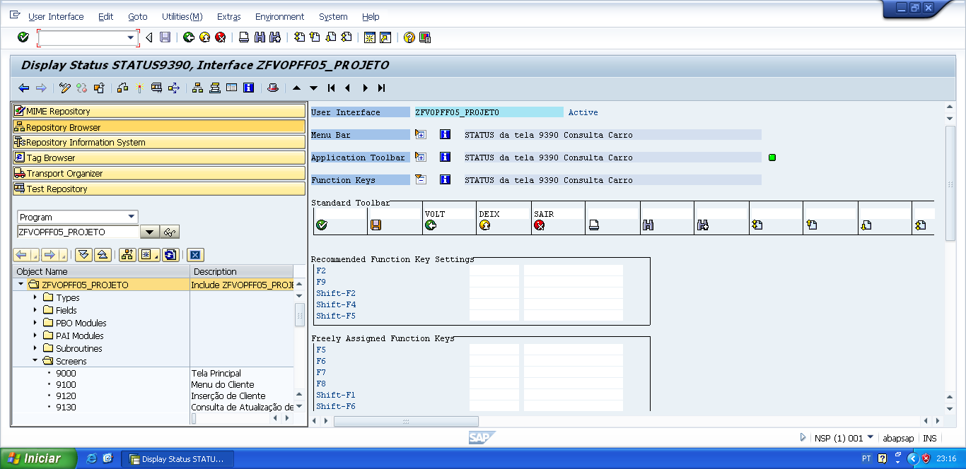

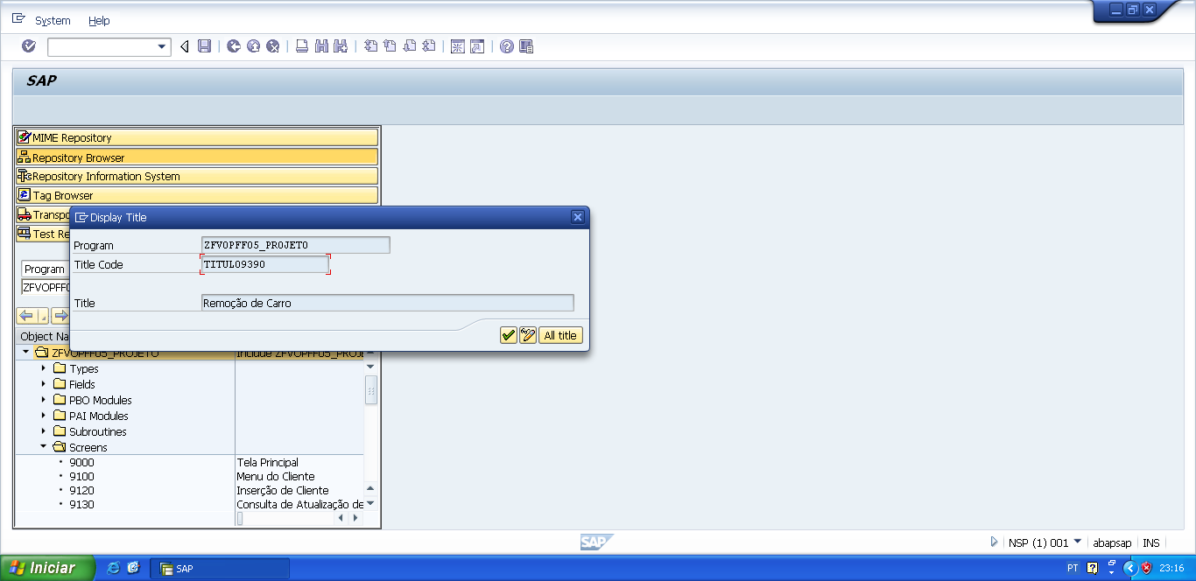

*&---------------------------------------------------------------------*  
*&      Module  M_PREENCHER_CARRO  OUTPUT  
*&---------------------------------------------------------------------*  
*       text  
*----------------------------------------------------------------------*  
MODULE m_preencher_carro OUTPUT.  
  
  PERFORM f_preencher_carro.  
  
ENDMODULE.                 " M_PREENCHER_CARRO  OUTPUT

*&---------------------------------------------------------------------*  
*&      Form  F_PREENCHER_CARRO  
*&---------------------------------------------------------------------*  
*       text  
*----------------------------------------------------------------------*  
*  -->  p1        text  
*  <--  p2        text  
*----------------------------------------------------------------------*  
FORM f_preencher_carro .  
  
  v_chassi_car = wa_zfvtpff05_carro-chassi_carro.  
  v_modelo_car = wa_zfvtpff05_carro-modelo_carro.  
  v_ano_car    = wa_zfvtpff05_carro-ano_carro.  
  v_cor_car    = wa_zfvtpff05_carro-cor_carro.  
  v_cnpj_forn  = wa_zfvtpff05_carro-cnpj_fornecedor.  
  v_cpf_cli    = wa_zfvtpff05_carro-cpf_cliente.  
  
ENDFORM.                    " F_PREENCHER_CARRO

PROCESS AFTER INPUT.  
   MODULE USER_COMMAND_9390.

*&---------------------------------------------------------------------*  
*&      Module  USER_COMMAND_9390  INPUT  
*&---------------------------------------------------------------------*  
*       text  
*----------------------------------------------------------------------*  
MODULE user_command_9390 INPUT.  
  
  v_okcode = sy-ucomm.  
  
  CASE v_okcode.  
    WHEN 'VOLT'.  
      PERFORM f_voltar.  
    WHEN 'DEIX'.  
      PERFORM f_deixar.  
    WHEN 'SAIR'.  
      PERFORM f_sair.  
*  
    WHEN 'DELC'.  
      PERFORM f_deletar_carro.  
  
  ENDCASE.  
  
  CLEAR v_okcode.  
  
ENDMODULE.                 " USER_COMMAND_9390  INPUT

*&---------------------------------------------------------------------*  
*&      Form  F_VOLTAR  
*&---------------------------------------------------------------------*  
* FORM de voltar, serve para voltar automaticamente para a tela  
*anterior da tela atual.  
*----------------------------------------------------------------------*  
*  -->  p1        text  
*  <--  p2        text  
*----------------------------------------------------------------------*  
FORM f_voltar.  
  
*Volte para á tela 9000 (Tela Principal)  
*ou  
**CALL SCREEN '9000'.**  
  PERFORM f_limpar_variaveis.  
  SET SCREEN 0.  
  LEAVE SCREEN.  
  
  
ENDFORM.                    " F_VOLTAR  
  
*&---------------------------------------------------------------------*  
*&      Form  F_DEIXAR  
*&---------------------------------------------------------------------*  
*       text  
*----------------------------------------------------------------------*  
*  -->  p1        text  
*  <--  p2        text  
*----------------------------------------------------------------------*  
FORM f_deixar .  
  
  LEAVE LIST-PROCESSING.  
  
ENDFORM.                    " F_DEIXAR  
  
*&---------------------------------------------------------------------*  
*&      Form  F_SAIR  
*&---------------------------------------------------------------------*  
*       text  
*----------------------------------------------------------------------*  
*  -->  p1        text  
*  <--  p2        text  
*----------------------------------------------------------------------*  
FORM f_sair.  
  
  LEAVE LIST-PROCESSING.  
  
ENDFORM.                    " F_SAIR

*&---------------------------------------------------------------------*  
*&      Form  F_DELETAR_CARRO  
*&---------------------------------------------------------------------*  
*       text  
*----------------------------------------------------------------------*  
*  -->  p1        text  
*  <--  p2        text  
*----------------------------------------------------------------------*  
FORM f_deletar_carro .  
  
  DELETE FROM zfvtpff05_carro WHERE chassi_carro = v_chassi_car.  
  
  IF sy-subrc IS INITIAL.  
* COMMIT WORK é quando realmente queremos deletar da tabela transparente.  
    COMMIT WORK.  
    MESSAGE s014(zfvclpff05) WITH v_chassi_car.  
    PERFORM f_limpar_variaveis.  
    CALL SCREEN '9330'.  
  
  ELSE.  
* ROLLBACK WORK é quando não queremos que delete da tabela transparente  
* não faca o que o COMMIT WORK faz.  
    ROLLBACK WORK.  
    MESSAGE s015(zfvclpff05) WITH v_chassi_car DISPLAY LIKE 'E'.  
  ENDIF.  
  
ENDFORM.                    " F_DELETAR_CARRO

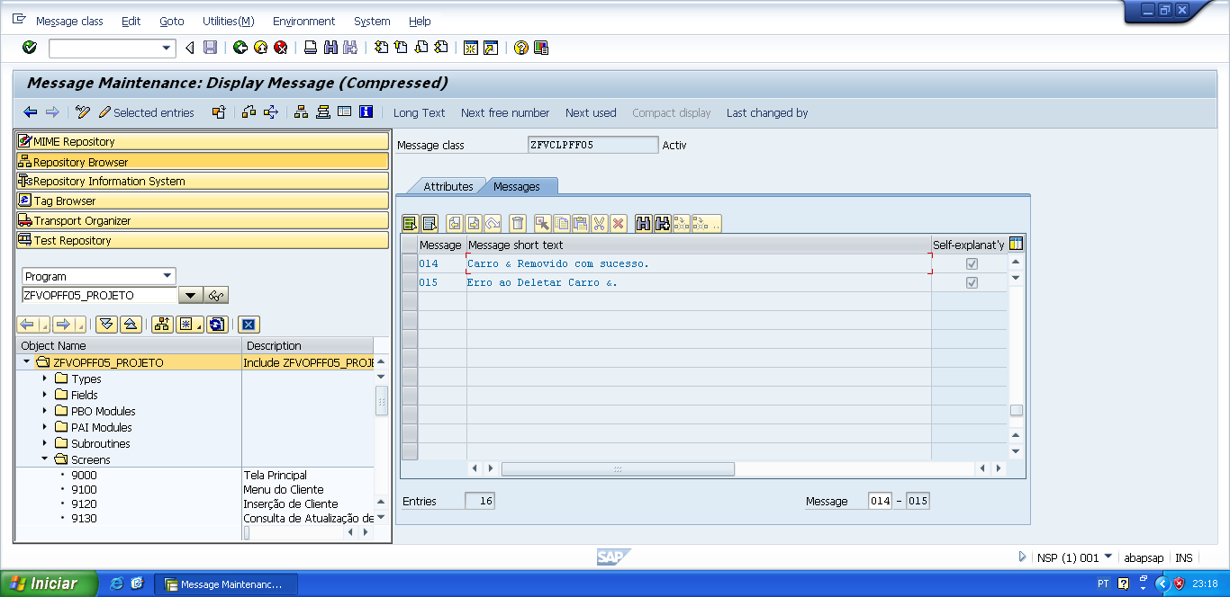

*&---------------------------------------------------------------------*  
*&      Form  F_LIMPAR_VARIAVEIS  
*&---------------------------------------------------------------------*  
*       text  
*----------------------------------------------------------------------*  
*  -->  p1        text  
*  <--  p2        text  
*----------------------------------------------------------------------*  
FORM f_limpar_variaveis.  
  
*limpar as variaveis usadas nas telas  
  CLEAR: v_cpf_cli,  
         v_nome_cli,  
         v_end_cli,  
         v_tel_pri_cli,  
         v_tel_sec_cli.  
*  
  CLEAR: v_cnpj_forn,  
         v_nome_forn,  
         v_end_forn,  
         v_tel_pri_forn,  
         v_tel_sec_forn.  
*  
  CLEAR: v_chassi_car,  
         v_modelo_car,  
         v_ano_car,  
         v_cor_car.  
  
  CLEAR: wa_zfvtpff05_client,  
         wa_zfvtpff05_fornec,  
         wa_zfvtpff05_carro.  
  
ENDFORM.                    " F_LIMPAR_VARIAVEIS

